STOCK PRICE PREDICTION

PHASE II REPORT

Submitted by
Supervisor:- Ms. Harsh Sharma (E13523)
Co Supervisor:- Mr. Siroj Kumar Singh (E13617)

NAME OF THE CANDIDATE(S)
NAME - UID
ANMOL SHAKYA - 20BCS5146
BUNTY PRASAD NAYAK - 20BCS1160
DEVANSH TIWARI - 20BCS1235

in partial fulfillment for the award of the degree of

BACHELOR OF ENGINEERING
IN
COMPUTER SCIENCE AND ENGINEERING


Chandigarh University
OCTOBER & 2022

CHAPTER 2.
LITERATURE REVIEW/BACKGROUND STUDY

Timeline of the reported problem
- The stock of a corporation constitutes the equity stake of its owners. it represents the residual assets of the company that would be due to stockholders after discharge of all senior claims such as secured and unsecured debt.
- Stock market prediction is the act of trying to determine the duture value of a company stock or other financial instrument traded on an exchange. The successful
prediction of a stock’s future price could yield significant profit.
- Whenever new information comes up the market absorbs it by correcting itself , thus there is no space for prediction . Example of crashes of market unexpected.

The Biggest Stock Market Crashes in History-

1. The Wall Street Crash of 1929-
The stock market began right around 1600, and the first stock market crash was soon to follow. However, the Black Tuesday stock market crash that took place in 1929 remains the worst stock market crash in US history.

2. The Tech Bubble Crash of 1999-
The 1990s were a period of rapid technological development, and the commercialization of the internet caused valuations of internet-based companies to soar.
3.The Housing Market Crash of 2008-
This is one you probably remember — the housing market collapse of 2008. Over the course of 2008, the Dow fell almost 34%, and it wasn’t until early 2009 that it began to climb again.

4.The Stock Market Crash of 2020-
This leads us to our most recent example: the stock market crash of 2020, which disrupted a ten-year all-time-high bull market. Though the crash was largely due to the impact of the coronavirus, many weaknesses within the market built up for years, creating a massive stock market bubble.That being said, it doesn’t take much for a market to crash. It only requires a specific set of circumstances to manifest within the economy.
And manifest they did. By April 2020, unemployment climbed to 14.8%.

Proposed solutions-
Stock market prediction seems a complex problem because there are many factors that have yet to be addressed and it doesn’t seem statistical at first. But by proper use of machine learning techniques, one can relate previous data to the current data and train the machine to learn from it and make appropriate assumptions. Machine learning as such has many models but this paper focuses on two most important of them and made the predictions using them.
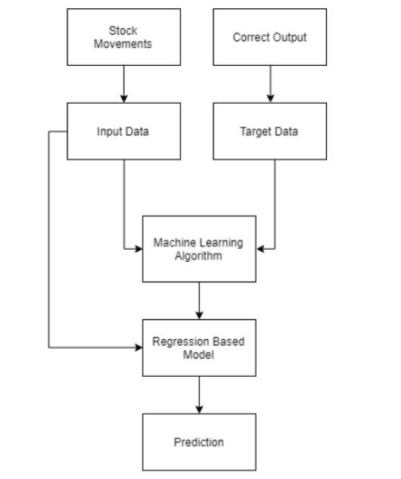
Fig1.Describe the proposed solution

Review Summary-
Two techniques have been utilized in this paper.LSTM and Regression, on the Yahoo finance dataset. Both the techniques have shown an improvement in the accuracy of predictions, thereby yielding positive results. Use of recently introduced machine learning techniques in the prediction of stocks have yielded promising results and thereby marked the use of them in profitable exchange schemes. It has led to the conclusion that it is possible to predict stock market with more accuracy and efficiency using machine learning techniques.
In the future, the stock market prediction system can be further improved by utilizing a much bigger dataset LSTM is the advanced version of Recurrent-Neural- Networks (RNN) where the information belonging to previous state persists. These are different from RNNs as they involve long term dependencies and RNNs works on finding the relationship between the recent and the current information. This indicates that the interval of information is relatively smaller than that to LSTM.
The main purpose behind using this model in stock market prediction is that the predictions depends on large amounts of data and are generally dependent on the long term history of the market . So LSTM regulates error by giving an aid to the RNNs through retaining information for older stages making the prediction more accurate .
Since stock market involves processing of huge data, the gradients with respect to the weight matrix may become very small and may degrade the learning rate of
the system. This corresponds to the problem of Vanishing Gradient. LSTM prevents this from happening. The LSTM consists of a remembering cell, input gate, output gate and a forget gate. The cell remembers the value for long term propagation and the gates regulate them .
In this paper, a sequential model has been made which involves stacking two LSTM layers on top of each other with the output value of 256. The input to the layer is in the form of two layer [0] and layer[1]. A dropout value of 0.3 has been fixed which means that 0.3 out of total nodes will be frozen during the training process to avoid over-fitting of data and increase the speed of the training process. At last, the core dense layer where each neuron is connected to every other in the next layer is added providing input of 32 parameters to the next core layer which gives output as 1. The model is compiled with a mean square cost function to maintain the error throughout the process and accuracy is chosen as a metric for the prediction .

Problem Definition
Stock Price Prediction by Machine Learning present to estimate the stock future value and machine learning technique like LSTM for existing work. This machine-learning algorithm is to perform the best predicting result of the stock future price. LSTM is capable to catching the modifications in the behaviour of the stock price for the indicated period in this proposed system. Propose a machine learning-based normalization for stock price prediction.. The data reflected the stock price at some time intervals for every day of the year. It contains various data like date, symbol, open price, close price, low price, high price and volume. Here, the data for only one company was considered. All the data was available in a file of CSV format which was first read and transformed into a data frame using the Pandas library in Python. The normalization of the data was performed through the sklearn library in Python and the data were divided into training and testing sets. The experiment set was kept as 20% of the available dataset. This paper focuses on two architecture Regression-based Model and LSTM. The Regression-based Model is employed for predicting unbroken values through some given autonomous values Regression uses a given linear function for predicting continuous values of the most important amongst them and made the predictions using these. LSTM architecture is able to identify the changes in trends which show evident from the result. LSTM is identified as the best model for the proposed methodology. This shows that the proposed system is capable of identifying some interrelation within the data. In the stock market, there may not always follow the same cycle or may not always be in a regular pattern for the changes that are occurred. The period of the existence will differ and the existence of the trend is based on the companies and the sectors. For investors, this type of analysis of trends and cycles will obtain more profit. We must use networks like LSTM as they rely on the current information to analyse various information.

Proposed Work-

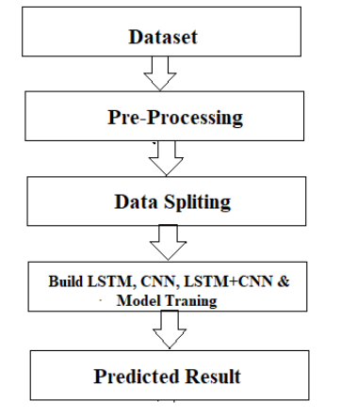
Fig2. Show the Implementation of the project

The system presented here composes of five modules:-
- Input as Dataset
- Pre processing
- Data splitting
- Build & Model train Lstm
- Output as Predicted Result.

Goals/Objectives
- A stock market prediction is described as an action of attempting to classify the future value of the company stock or other financial investment traded on the stock exchange. The forthcoming price of a stock of the successful estimation is called the Yield significant profit. This helps you to invest wisely for making good profits.
- The future price of a stock is the main motivation behind the stock price prediction. In various cases like business and industry, environmental science, finance and economics motivation can be useful. The future value of the company’s stock can be determining.

REFERENCES
- A. Ben-Hur and J. Weston. A user's guide to support vector machines. In O. Carugo and F. Eisenhaber (eds.), Data Mining Techniques for the Life Sciences, pp. 223--239. Springer, 2010.
- Bing Search API. Windows Azure Marketplace.
- N. K. Chowdhury and C. K.-S. Leung. Improved travel time prediction algorithms for intelligent transportation systems. In Proc. KES 2011, Part II, pp. 355--365.
- A. Cuzzocrea, C. K.-S. Leung, and R. K. MacKinnon. Mining constrained frequent itemsets from distributed uncertain data. FGCS, 37: 117--126, July 2014.
- T. Finley and T. Joachims. Training structural SVMs when exact inference is intractable. In Proc. ICML 2008, ACM, pp. 304--311. ACM.
- D. Hodges. Is your fund manager beating the index? MoneySense, 15(7):10, Dec. 2013/Jan. 2014.
- T. Joachims, T. Finley, and C.-N. J. Yu. Cutting-plane training of structural SVMs. Machine Learning, 77(1): 27--59, Oct. 2009.
- D. E. King. Dlib-ml: a machine learning toolkit. JMLR, 10: 1755--1758, July 2009.
- V. Kolmogorov and C. Rother. Minimizing nonsubmodular functions with graph cuts-a review. IEEE TPAMI, 29(7): 1274--1279, July 2007.
C. K.-S. Leung, F. Jiang, and Y. Hayduk. A landmark-model based system for mining frequent patterns from uncertain data streams. In Proc. IDEAS 2011, pp. 249--250. ACM.

